Distributed hash tables

A distributed hash table (DHT) is a type of distributed system that provides a lookup service similar to a hash table. In a hash table, data is stored and retrieved using keys, and the keys are used to determine the location of the data in the table. A distributed hash table is similar, but the data is distributed across multiple nodes in a network rather than being stored in a single table.

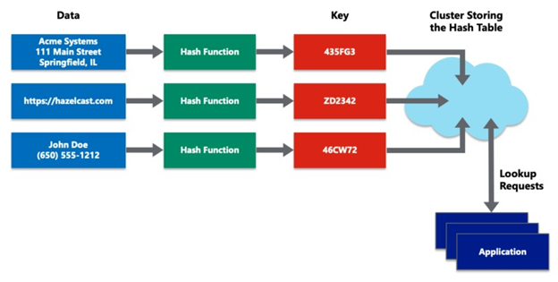

In a DHT, each node is responsible for storing and managing a portion of the data. When a client wants to retrieve or store data, it sends a request to the network. The request is then forwarded to the appropriate node based on the key of the data being requested. The node then responds to the request and either retrieves or stores the data. DHTs are used in a variety of applications, including peer-to-peer (P2P) networks, distributed databases, and distributed file systems.

Blockchain and full ecosystem decentralization

The blockchain is a distributed ledger that runs on top of conventional systems. These elements include storage, communication, and computation. There are other factors, such as identity and wealth, which are traditionally based on centralized paradigms, and there's a need to decentralize these aspects as well in order to achieve a sufficiently decentralized ecosystem.

Storage

Data can be stored directly in a blockchain, and with this fact it achieves decentralization. However, a significant disadvantage of this approach is that a blockchain is not suitable for storing large amounts of data by design. It can store simple transactions and some arbitrary data, but it is certainly not suitable for storing images or large blobs of data, as is the case with traditional database systems.

A better alternative for storing data is to use distributed hash tables (DHTs). DHTs were used initially in peer-to-peer file-sharing software, such as BitTorrent, Napster, Kazaa, and Gnutella. DHT research was made popular by the CAN, Chord, Pastry, and Tapest1Y projects. BitTorrent is the most scalable and fastest network, but the issue with BitTorrent and the others is that there is no incentive for users to keep the files indefinitely.

Users generally don't keep files permanently, and if nodes that have data still required by someone leave the network, there is no way to retrieve it except by having the required nodes rejoin the network so that the files once again become available.

Two primary requirements here are high availability and link stability, which means that data should be available when required and network links also should always be accessible. Inter-Planetary File System (IPFS) by Juan Benet possesses both of these properties, and its vision is to provide a decentralized World Wide Web by replacing the HTTP protocol. IPFS uses Kademlia DHT and Merkle

Directed Acyclic Graphs (DAGs) to provide storage and searching functionality, respectively.

The incentive mechanism for storing data is based on a protocol known as Filecoin, which pays incentives to nodes that store data using the Bitswap mechanism. The Bitswap mechanism lets nodes keep a simple ledger of bytes sent or bytes received in a one-to-one relationship. Also, a Git-based version control mechanism is used in IPFS to provide structure and control over the versioning of data.

There are other alternatives for data storage, such as Ethereum Swarm, Storj, and MaidSafe. Ethereum has its own decentralized and distributed ecosystem that uses Swarm for storage and the Whisper protocol for communication. MaidSafe aims to provide a decentralized World Wide Web.

BigChainDB is another storage layer decentralization project aimed at providing a scalable, fast, and linearly scalable decentralized database as opposed to a traditional filesystem. BigChainDB complements decentralized processing platforms and filesystems such as Ethereum and IPFS.

Communication

The Internet (the communication layer in blockchain) is considered decentralized. This belief is correct to some extent, as the original vision of the Internet was to develop a decentralized communications system. Services such as email and online storage are now all based on a paradigm where the service provider is in control, and users trust such providers to grant them access to the service as requested. This model is based on the unconditional trust of a central authority (the service provider) where users are not in control of their data. Even user passwords are stored on trusted third-party systems.

Thus, there is a need to provide control to individual users in such a way that access to their data is guaranteed and is not dependent on a single third party. Access to the Internet (the communication layer) is based on Internet Service Providers (ISPs) who act as a central hub for Internet users. If the ISP is shut down for any reason, then no communication is possible with this model.

An alternative is to use mesh networks. Even though they are limited in functionality when compared to the Internet, they still provide a decentralized alternative where nodes can talk directly to each other without a central hub such as an ISP.

Blockchain has revived the vision of decentralization across the world, and now concerted efforts are being made to harness this technology and take advantage of the benefits that it can provide.

Computing power and decentralization

Decentralization of computing or processing power is achieved by a blockchain technology such as Ethereum, where smart contracts with embedded business logic can run on the blockchain network. Other blockchain technologies also provide similar processing-layer platforms, where business logic can run over the network in a decentralized manner.

The following diagram shows an overview of a decentralized ecosystem. In the bottom layer, the Internet or mesh networks provide a decentralized communication layer. In the next layer up, a storage layer uses technologies such as IPFS and BigChainDB to enable decentralization. Finally, in the next level up, you can see that the blockchain serves as a decentralized processing (computation) layer. Blockchain can, in a limited way, provide a storage layer too, but that severely hampers the speed and capacity of the system. Therefore, other solutions such as IPFS and BigChainDB are more suitable for storing large amounts of data in a decentralized way. The Identity and Wealth layers are shown at the top level. Identity on the Internet is a vast topic, and systems such as bitAuth and OpenID provide authentication and identification services with varying degrees of decentralization and security assumptions:

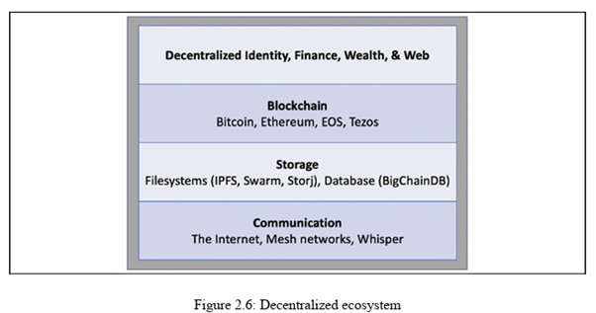

The blockchain is capable of providing solutions to various issues relating to decentralization. A concept relevant to identity known as Zooko's Triangle requires that the naming system in a network protocol is secure, decentralized, and able to provide human-meaningful and memorable names to the users. Conjecture has it that a system can have only two of these properties simultaneously.

Nevertheless, with the advent of blockchain in the form of Namecoin, this problem was resolved. It is now possible to achieve security, decentralization, and human-meaningful names with the Namecoin blockchain. However, this is not a panacea, and it comes with many challenges, such as reliance on users to store and maintain private keys securely. This opens up other general questions about the suitability of decentralization to a particular problem.

Decentralization may not be appropriate for every scenario. Centralized systems with well-established reputations tend to work better in many cases. For example, email platforms from reputable companies such as Google or Microsoft would provide a better service than a scenario where individual email servers are hosted by users on the Internet. There are many projects underway that are developing solutions for a more comprehensive distributed blockchain system.